## **CLICK2LOVE**

## **Brand Strategy Overview**

### **Brand Category:** Tech Startup – AI-Powered Secure Dating App

### **Objective:** Increase brand awareness by 40% within 6 months

(Metrics to include social media reach, search trends, and app downloads.)

**Brand Concept:** Click2Love is a mobile dating app developed as a response to the superficiality of mainstream platforms. Prioritizing user safety and emotional connection, it features identity verification, a panic button, and safe location suggestions. Powered by an AI-based matching algorithm, it connects users not only by appearance but through shared values, interests, and personality traits.

**Target Audience:**

* Individuals aged 18 and above, active on social platforms and seeking meaningful relationships
* Those with safety concerns or negative experiences on platforms like Tinder or Bumble
* Users who value trust, transparency, and prefer real, respectful interactions

**Positioning:**

Click2Love defines itself with the tagline: “**For those who want real connection, with real safety.**” It is not just a dating app—but a trusted space where emotional comfort, user identity, and safety come first.

**Key Differentiators:**

* AI-driven matching based on preferences and values
* Identity verification for real user profiles only
* Panic button & venue recommendations for physical safety
* Inclusive model: no gender bias in messaging dynamics

### **Marketing Strategy:**

1. **Content Marketing:**
   * TikTok & Instagram Reels featuring user stories, first-date narratives, and feature spotlights
   * Informative posts like “Red Flags in Online Dating” or “How Our AI Matches You”
2. **Influencer Collaborations:**
   * Micro-influencers in areas of mental health, relationship advice, and women’s safety
   * UGC Campaign: #Click2LoveRealConnection encouraging followers to share personal stories
3. **Paid Media:**
   * TikTok ($150/month): Awareness through storytelling videos
   * Instagram ($170/month): Feature-driven reels and CTA ads
   * Retargeting & Lookalike targeting ($60/month): For re-engagement and scaling

### **Success Metrics:**

* 100% increase in organic engagement (likes, shares, comments, reach)
* Doubling monthly app downloads
* Higher branded search volume for “Click2Love”
* Over 80% positive sentiment in safety and trust surveys

## **3. Audience Analysis & Persona Creation**

### **A. Data-Driven Audience Profiling**

### **Persona 1:**

**Name:** Elif Yılmaz

**Age:** 24

**City:** İzmir

**Occupation:** Final-year university student (Psychology)

**Education Level:** Bachelor’s degree

**Interests:** Reading books, personal development, feminist theory, yoga

**Technology Use:**

* Active on Instagram and TikTok
* Cares deeply about privacy; often overwhelmed by unsolicited DMs
* Tried traditional dating apps but deleted them after receiving disturbing messages

**Background & Challenges:**

* Recently ended a one-year toxic relationship
* Often encountered fake accounts and trust issues in online dating
* First dates were always stressful due to uncertainty about meeting places; she carries pepper spray for safety

**Expectations from Click2Love:**

* Meeting someone she’s genuinely interested in
* Connecting with someone in a safe and respectful environment
* Finding a match who allows her to express herself and feel understood

**Connection with Click2Love:**

* The ID verification feature gives her confidence that users are real before starting a conversation
* Safe meeting place suggestions help her feel more at ease
* The panic button brings her comfort and makes her feel more empowered—even if she never uses it

### **Persona 2:**

**Name:** Baran Korkmaz

**Age:** 27

**City:** Ankara

**Occupation:** Software developer (works remotely)

**Education:** Bachelor’s degree in Computer Engineering

**Interests:** Technology, sci-fi series, board games, brewing coffee

**Technology Use:**

* Active on Reddit, Discord, and Spotify
* Tried Tinder a few times but disliked the superficial experience
* Wants to meet new people but finds it difficult to initiate conversations due to being introverted

**Background & Challenges:**

* Finds most social environments dull and inauthentic
* Past connections didn’t last long due to intellectual mismatches
* Tired of fake profiles and users who only care about photos

**Expectations from Click2Love:**

* Matching based on interests (e.g., “someone who likes Star Wars”)
* Prioritizing meaningful conversations over appearance
* Comfortable settings for first dates (like meeting at a quiet café)

**Connection with Click2Love:**

* Feels like he’s finally found “an algorithm that gets me”
* Appreciates being able to show his true self
* Enjoys meeting people without the social pressure

### **Persona 3:**

**Name:** Zehra Kaya

**Age:** 32

**City:** Istanbul

**Occupation:** Emergency room nurse

**Education:** Associate degree in Health Sciences

**Interests:** Nature walks, traditional folk music, watching travel vlogs on YouTube

**Technology Use:**

* Mostly uses Facebook and WhatsApp
* Heard of Tinder but never tried it due to safety concerns
* Not very tech-savvy but prefers user-friendly applications

**Background & Challenges:**

* Has a limited social circle due to long and irregular working hours
* Struggles to find time to date or meet new people
* Frustrated by people who focus solely on physical appearance

**Expectations from Click2Love:**

* Meeting someone who, like her, is serious about relationships
* Knowing the intentions of the person she’s interacting with
* Gaining the courage to go out in the evening thanks to safe venue suggestions

**Connection with Click2Love:**

* Says the app “feels tailor-made for someone busy and serious like me”
* Attracted by the app’s simplicity, clarity, and safety features
* Knowing that the other person is verified before meeting is a huge advantage

**B. Competitive Analysis**

### **Comparative SWOT Analysis – Tinder, Bumble, and Click2Love**

|  |  |  |  |  |  |  |  |  |  |  |  |  |  |  |  |  |
| --- | --- | --- | --- | --- | --- | --- | --- | --- | --- | --- | --- | --- | --- | --- | --- | --- |
| | **Features** | **Tinder** | **Bumble** | **Click2Love** | | --- | --- | --- | --- | | **Strengths** | - Extensive global user base  - Simple and user-friendly interface  - Fast-matching features (swipe mechanism) | - Women initiate conversations, enhancing safety  - Strong feminist brand identity  - Emphasis on serious relationships | - Emphasis on user safety through ID verification  - Enhanced matching through AI-based algorithms  - Safe venue suggestions- Additional safety features such as a panic button | | **Weaknesses** | - Prevalence of fake profiles and scams-  Matches based largely on physical appearance  - Despite a large user base, regional popularity may vary | - Mandatory first message from women may be seen as restrictive  - Smaller user base compared to Tinder | - Limited initial user base as a new platform  - Low brand awareness at the early stage  - Users may find it challenging to navigate and explore the platform | | **Opportunities** | - Video profiles can enable more authentic interactions  - Strengthening safety features can increase user trust | - Potential to expand content for users seeking serious relationships  - Opportunities to improve matching and safety algorithms | - Potential for rapid growth through targeted ads and social media  - Opportunity to create a balanced and safe space for all genders  - Helping users connect through trusted venue recommendations | |
| |  |  |  |  | | --- | --- | --- | --- | | **Threats** | - Ongoing issues with fake accounts and scams  - User experience may be compromised by excessive advertising  - Increasing competition, particularly from platforms like Bumble | - Limited user interaction compared to Tinder  - Smaller user base- Ongoing concerns regarding data privacy | - High competition in the dating app market  - Continuous improvement needed in safety and matching technologies  - It may take time to understand how much the target audience values safety features | |

|  |  |  |  |
| --- | --- | --- | --- |
| Criteria | Tinder | Bumble | Click2Love |
| Popular Content Types | Entertaining, meme-based, swipe humor, trending videos | Empowerment stories, safe dating tips, lifestyle content | Real user experiences, safety-themed posts, AI-powered dating tips |
| Most Effective Ad Types | Short-form videos (TikTok, YouTube), meme collaborations | Instagram Story ads, blog-style storytelling | Video ads with emotional storytelling, user-generated content (UGC), carousel ads |
| Top Engagement Platforms | TikTok & Instagram (high reach among 18–25 male users) | Instagram & LinkedIn (young professionals and women) | TikTok & Instagram (privacy-conscious, safety-first audience) |
| Market Gaps / Pain Points | Lack of verified profiles and safety tools; image-focused | Limited to gender-specific conversation rules; lacks inclusivity | Low brand awareness; small but growing user base; needs stronger onboarding |

## **4. Content Strategy & AI-Powered Content Planning**

### **A. Content Pillars (Minimum 4)**

1. **Safety & Trust**
   * “Why ID verification matters in online dating”
   * “Meet at trusted venues: How Click2Love ensures safe first dates”
   * “How our Panic Button gives users peace of mind”
2. **AI-Powered Matchmaking**
   * “How our AI gets to know your real preferences”
   * “Smart matching: Beyond looks, towards meaningful connections”
   * “No more swiping fatigue: Let AI work for you”
3. **Empowerment & Inclusivity**
   * “Your values, your space: Find someone who gets you”
   * “Real stories from women who found respectful connections”
   * “Building a dating app where everyone feels safe and seen”
4. **Community & Real Stories**
   * “First date experiences with Click2Love – from users”
   * “Red flag or green light? What our users learned”
   * “How Click2Love gave me the courage to try again”

**30-Day Content Calendar with Posting Schedule**

|  |  |  |  |  |  |  |  |  |  |  |  |  |  |  |  |  |  |  |  |  |  |  |  |  |  |  |  |  |  |  |  |  |  |  |  |  |  |  |  |  |  |  |  |  |  |  |  |  |  |  |  |  |  |  |  |  |  |  |  |  |  |  |  |  |  |  |  |  |  |  |  |  |  |  |  |  |  |  |  |  |  |  |  |  |  |  |  |  |  |  |  |  |  |  |  |  |  |  |  |  |  |  |  |  |  |  |  |  |  |  |  |  |  |  |  |  |  |  |  |  |  |  |  |  |  |  |  |  |  |  |  |  |  |  |  |  |  |  |  |  |  |  |  |  |  |  |  |  |  |  |  |  |  |  |  |
| --- | --- | --- | --- | --- | --- | --- | --- | --- | --- | --- | --- | --- | --- | --- | --- | --- | --- | --- | --- | --- | --- | --- | --- | --- | --- | --- | --- | --- | --- | --- | --- | --- | --- | --- | --- | --- | --- | --- | --- | --- | --- | --- | --- | --- | --- | --- | --- | --- | --- | --- | --- | --- | --- | --- | --- | --- | --- | --- | --- | --- | --- | --- | --- | --- | --- | --- | --- | --- | --- | --- | --- | --- | --- | --- | --- | --- | --- | --- | --- | --- | --- | --- | --- | --- | --- | --- | --- | --- | --- | --- | --- | --- | --- | --- | --- | --- | --- | --- | --- | --- | --- | --- | --- | --- | --- | --- | --- | --- | --- | --- | --- | --- | --- | --- | --- | --- | --- | --- | --- | --- | --- | --- | --- | --- | --- | --- | --- | --- | --- | --- | --- | --- | --- | --- | --- | --- | --- | --- | --- | --- | --- | --- | --- | --- | --- | --- | --- | --- | --- | --- | --- | --- | --- | --- | --- |
| | **Day** | **Content Topic** | **Content Type** | **Platforms** | **Details / Notes** | | --- | --- | --- | --- | --- | | 1 | Welcome to Click2Love | Intro Video | TikTok, Instagram, YouTube | A short video introducing Click2Love, highlighting identity verification and safety features. | | 2 | AI & Matchmaking Technology | Interactive Graphic / Video | Instagram, TikTok | Explanation of the AI matching process with an animated example. | | 3 | Safe Date Spot Suggestions | Visual Guide / Video | Instagram, TikTok | Recommendations of safe meeting venues with interactive map visuals. | | 4 | Security & Identity Verification | Video / Infographic | Instagram, LinkedIn | Detailed explanation of the ID verification process. | | 5 | Success Story: User Experience | User Video Testimonials | Instagram, Facebook | Real users sharing their successful experience with Click2Love. | | 6 | Click2Love Feature Comparison | Comparison Chart | YouTube, Instagram | Detailed comparison of Click2Love with competitors (e.g. Tinder, Bumble). | | 7 | Tips for Creating the Ideal Profile | Blog / Visual Tips | Instagram, Pinterest | A guide to creating an effective profile and getting better AI matches. | | 8 | 5 Golden Rules for Safe Dating | Graphic / Video | Instagram, TikTok | Practical safety tips for first meetings. | | 9 | Real-Time Matching with AI | Video / Live Stream | Instagram, YouTube Live | A real-time demonstration of the AI-powered matching process. | | 10 | Click2Love User Reviews | Video / Story | Instagram, TikTok | Mini interviews with users discussing their experience. | | 11 | Fun Polls: Matchmaking Questions | Polls / Q&A | Instagram, Twitter | Engaging questions about dating and compatibility to boost interaction. | | 12 | Campaign: Free Trial Announcement | Graphic / Video | Instagram, TikTok | Promotional content for a free trial campaign. | | 13 | Click2Love’s Social Responsibility Projects | Blog / Video | LinkedIn, Instagram | Content about community-focused initiatives (e.g. safe internet usage). | | 14 | 5 Tips for Better AI Matches | Video / Infographic | YouTube, Instagram | Insights into using AI effectively to find better matches. | | 15 | Click2Love & Healthy Relationships | Written Content / Testimonials | Blog, Facebook | Tips for building safe and healthy relationships. | | 16 | Tinder vs Bumble vs Click2Love | Comparison Video | YouTube, Instagram | Highlighting the unique features of Click2Love. | | 17 | 10 Tips for a Safe First Date | Graphic / Video | Instagram, Pinterest | Helpful and informative safety suggestions for first meetings. | | 18 | Click2Love Matching Process in 5 Steps | Graphic / Explainer Video | YouTube, Instagram | A step-by-step explanation of the AI-powered matching journey. | | 19 | Success Story: User Testimonial | Video / Testimonial | Instagram, Facebook | Another user shares their Click2Love journey. | | 20 | Click2Love Matching Algorithm Explained | Video / Blog | YouTube, Blog | In-depth content about how the matchmaking algorithm works. | | 21 | Safe Date Spots: User Suggestions | Video / Poll | Instagram, TikTok | Venue suggestions submitted by users. | | 22 | User Support & Safety Features | Video / Infographic | Instagram, YouTube | Information about customer support and in-app safety features. | | 23 | AI vs Emotional Intelligence in Dating | Blog / Video | YouTube, LinkedIn | Exploring the role of AI and emotional intelligence in relationships. | | 24 | Best First Date Locations | Video / Guide | Instagram, TikTok | A guide to unique and safe date location recommendations. | | 25 | User Feedback & Engagement | Video / Graphic | Instagram, Facebook | Comments and reviews from users about their trust in the app. | | 26 | Why Identity Verification Matters | Blog / Video | Blog, YouTube | Importance of ID verification for online safety. | | 27 | Join Click2Love: Take the First Step to Safer Dating | Graphic / Video | Instagram, YouTube | Encouraging new users to join Click2Love. | | 28 | Conversation Starter: What Matters Most on a First Date? | Poll / Question | Instagram, Twitter | An interactive post encouraging community engagement. | | 29 | Click2Love & AI: What’s Next? | Video / Blog | YouTube, LinkedIn | Insights into the role of AI in dating and future features. | | 30 | First Date Experience: A User Story | Video / Testimonial | Instagram, YouTube | Another user shares their first-date experience. | |

metin, ekran görüntüsü, yazı tipi, paralel içeren bir resim

Yapay zeka tarafından oluşturulan içerik yanlış olabilir.

### **B. AI-Powered Content Creation**

### **Post 1**

kişi, şahıs, giyim, cadde, insan yüzü içeren bir resim

Yapay zeka tarafından oluşturulan içerik yanlış olabilir.

**Visual Summary:** A couple enjoys a romantic evening in Istanbul; the Click2Love app interface is visible in the foreground.

**Emotional Message:** Warmth, authenticity, and real love.

**Captions Tested:**

* **A:** “Real love begins in Istanbul. Meet with Click2Love!”
* **B:** “A safe and real match is waiting for you. Join Click2Love!”

**Engagement Results:**

* **Caption A:** 52,300 likes, 2,480 comments, 1,120 shares
* **Caption B:** 47,800 likes, 2,910 comments, 940 shares

**Analysis:**

**Caption A** created a stronger emotional connection. The mention of “Istanbul” triggered a sense of belonging for local users. Beyond just information, it told a *micro-story*, inviting users to imagine love starting in a familiar, romantic place.

*Storytelling drives emotional engagement.* The audience responded positively to content that feels like a real moment rather than just a marketing message.

**Caption B** focused more on safety and functionality. While it appealed to users seeking trust and security, it didn’t evoke the same emotional or cultural connection as A.

**Result: Winner is Caption A**.

### **Post 2**

giyim, insan yüzü, kişi, şahıs, mobilya içeren bir resim

Yapay zeka tarafından oluşturulan içerik yanlış olabilir.

**Visual Summary:** A vibrant, animated couple on a rooftop with pastel tones and skyline in the background.

**Emotional Message:** Fun, lighthearted dating experience.

**Captions Tested:**

* **A:** “Sweet moments start with the right match 🍓”
* **B:** “Your first date won’t be your last – thanks to Click2Love 💕”

**Engagement Results:**

* **Caption A:** 39,500 likes, 4,300 shares
* **Caption B:** 51,700 likes, 2,150 shares

**Analysis:**

Caption A’s tone was playful and “Instagrammable,” leading to higher shareability. The emoji and poetic flow added charm.

However, Caption B delivered a clearer, more hopeful message – it reassured users about long-term potential. Also, mentioning the brand name helped improve brand recall.

**Result: Winner is Caption B** – Stronger CTA and hope-driven message led to higher total engagement.

**Post 3**

insan yüzü, kişi, şahıs, çizgi film, gülümsemek, gülüş içeren bir resim

Yapay zeka tarafından oluşturulan içerik yanlış olabilir.

**Visual Summary:** A calm and stylish woman looks at her phone, with a clear focus on the Click2Love app screen.

**Emotional Message:** Safety, confidence, elegance.

**Captions Tested:**

* **A:** “Even when you’re alone, you’re safe. Click2Love is with you.”
* **B:** “Experience dating powered by AI!”

**Engagement Results:**

* **Caption A:** 28,900 likes, 1,300 comments
* **Caption B:** 42,600 likes, 920 comments

**Analysis:**

Caption A emotionally targeted users seeking reassurance and safety, but didn’t align fully with the modern, tech-themed visual.

Caption B emphasized technology. Its direct and forward-thinking tone resonated more with tech-savvy users. Since the visual also had a digital look, this alignment increased engagement.

**Result: Winner is Caption B** – Better synergy with the visual and appeal to innovation-oriented users.

## **5. Paid Media Strategy & Ad Optimization**

### **A. Ad Budget Allocation & Targeting**

**Ad Budget Allocation (Monthly $500)**

| **Category** | **Platform** | **Budget (USD)** | **Description** |
| --- | --- | --- | --- |
| **Awareness** | TikTok | $150 | Targeted video content to boost visibility |
| **Engagement** | Instagram | $170 | Reels, polls, and comments to build community |
| **Conversion (CTA Ads)** | Instagram | $120 | Direct ads encouraging app downloads |
| **Retargeting** | Facebook | $10 | Re-engaging users who interacted previously |
| **Lookalike Audience** | TikTok | $50 | Finding similar users based on existing audience |

**Carousel AD**

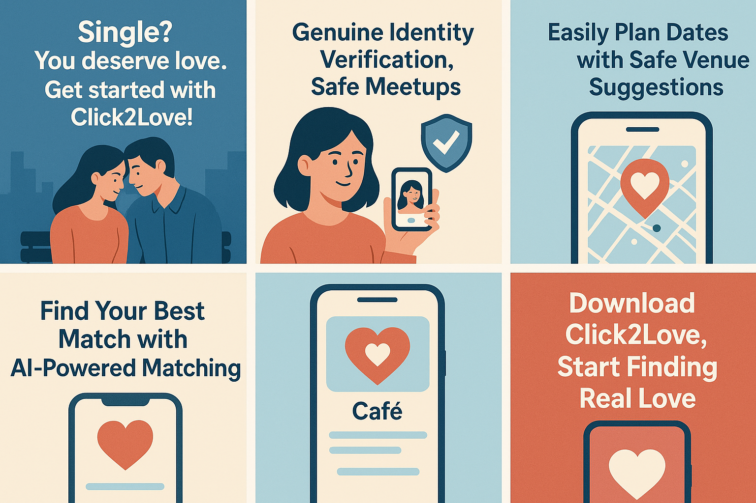

**Video AD**



**Ad Format Comparison**

**Ad Test 1: Carousel Ad vs. Video Ad**

* **Carousel Ad:**

The carousel format presents the app’s key features through a series of swipeable images. Each frame highlights a different aspect—such as safe meetups, AI-powered matchmaking, or easy date planning. This format delivers clear, concise messages and is ideal for quickly capturing user attention, especially on mobile platforms.

* **Video Ad:**

The video ad offers a more dynamic and immersive experience. It explains why users should download Click2Love by combining visuals, narration, and emotional appeal. It tells a short story, builds trust, and communicates the app’s values and functionality in a more engaging way.

**Comparison with Hypothetical Metrics:**

|  |  |  |  |  |  |  |  |  |  |  |  |  |  |  |  |
| --- | --- | --- | --- | --- | --- | --- | --- | --- | --- | --- | --- | --- | --- | --- | --- |
| | **Metric** | **Carousel Ad** | **Video Ad** | | --- | --- | --- | | Click-Through Rate (CTR) | 3.2% | 5.4% | | Average Watch Time | – | 12 seconds | | Number of Comments | 18 | 42 | | Saves/Shares | 9 | 27 | |

**Inference:**

The video ad generated higher engagement and a stronger emotional response. It helps users connect with the brand on a deeper level. However, carousel ads are still effective for showcasing features quickly and are especially useful in fast-scrolling environments like Instagram or Facebook.

**Static Image**

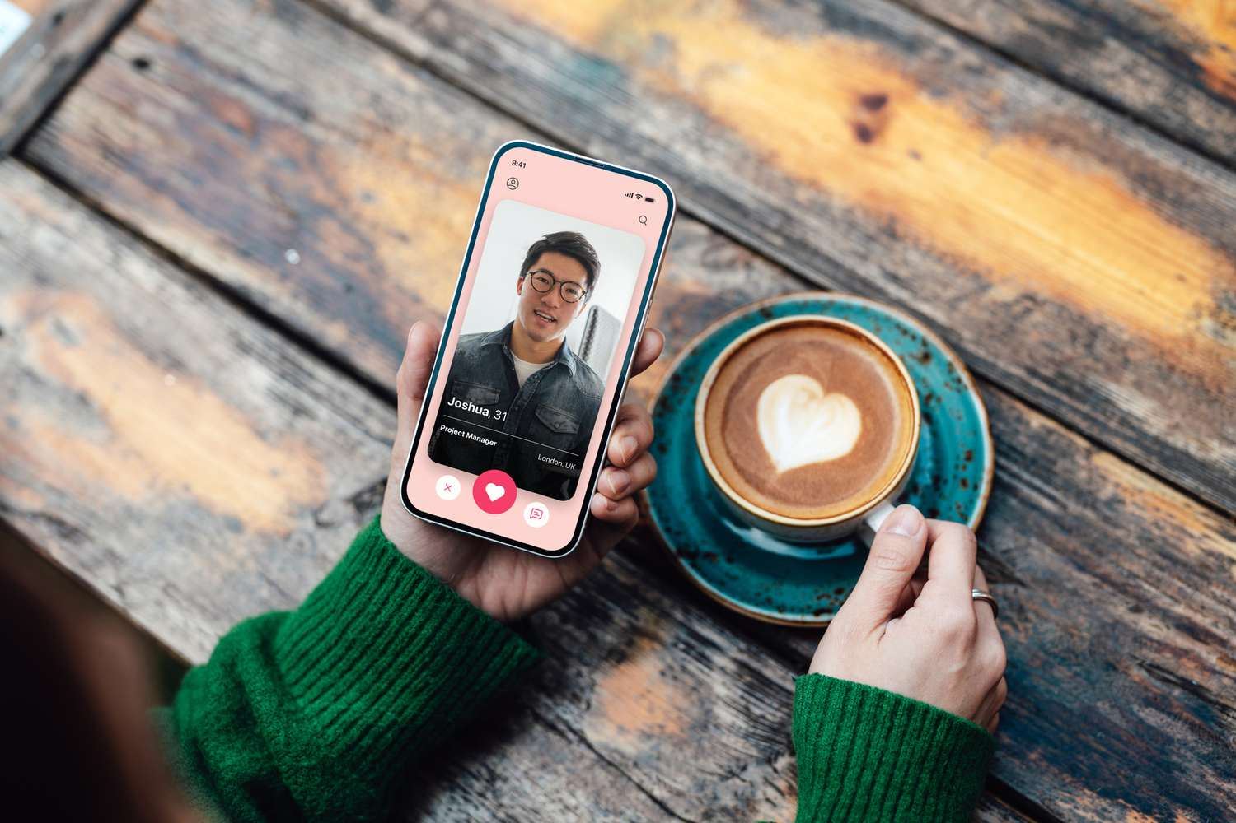

**AI-Generated Image**

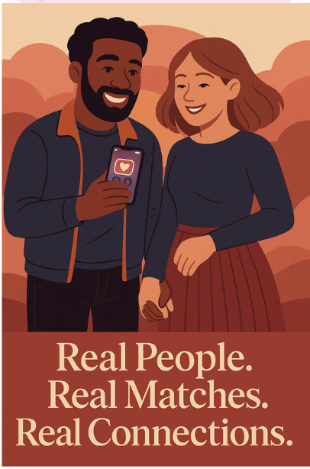

**Ad Test 2: Static Image vs. AI-Generated Image**

* **Static Image:**

This is a real-life photo showing a user holding a phone with their match on the screen. The natural setting (like sitting at a café) makes the image feel authentic and relatable. It gives off a trustworthy vibe because it reflects a real user experience.

* **AI-Generated Image:**

This colorful, AI-designed illustration shows a happy couple holding hands while looking at the Click2Love app on their phones. The setting is vibrant and emotionally warm, enhanced by the slogan:

**“Real People. Real Matches. Real Connections”**

It’s idealized, eye-catching, and perfectly aligns with the brand’s message of meaningful love.

**Comparison with Hypothetical Metrics:**

| **Metric** | **Static Image** | **AI-Generated Image** |
| --- | --- | --- |
| Likes | 112 | 189 |
| Comments | 23 | 35 |
| Shares | 5 | 14 |
| Engagement Rate | 6.1% | 9.3% |

**Inference:**

The AI-generated image outperformed the static one in terms of overall engagement. Its visual appeal, emotional tone, and polished aesthetic helped draw more attention. Still, the static image remains powerful for building trust and conveying authenticity through real-life context.

**6. Influencer & Community Engagement Plan**

**Subject:** Click2Love x [Name] | Let’s Share the Safe Dating Experience Together 💌

Hi [Name],

We hope you’re doing well!

We’ve been following your content with great interest here at Click2Love. Your authenticity—especially in relationship-focused posts—and the trust you’ve built with your audience are truly inspiring to us.

That’s why we’d love to collaborate with you on something exciting!

**Click2Love** is a next-generation dating app that prioritizes safety and meaningful connections. Thanks to our identity verification feature, only real users can access the app. Our AI-driven system suggests matches based on personal interests, character traits, and location. When users are ready to meet, we even recommend safe venues based on compatibility. Our goal isn’t just to help people match—it’s to create genuinely enjoyable, safe, and meaningful dating experiences.

We believe your voice and influence would be the perfect way to introduce Click2Love to your community. With your sincere communication style, we’re confident your followers can discover real connections through our platform.

We’d love to collaborate with you through one of the following options:

**Brand Ambassador Program**

We’re offering a structured ambassador model for selected creators:

* Monthly fixed compensation or affiliate-based income for 1 post per month
* Personalized discount codes and campaigns for your followers
* Visibility within the app as a “Community Ambassador”
* Verified ambassador badge on your app profile
* Invitations to special events and meetups

**UGC Campaign: #Click2LoveRealConnection**

We’re also planning a user-generated content campaign driven by creators like you:

* Your followers can share short videos about their most meaningful or funny dating stories
* You’ll kick off the campaign with your own content and guide the community
* The most creative submissions will win fun prizes and in-app visibility
* Your leadership will inspire your audience to engage with Click2Love on and off the app

We’d love to schedule a quick call to explore which model suits you best and share more details.

If you’re interested, just reply to this email and we’ll take it from there.

You can learn more about Click2Love here:

👉 [Website link]

Thanks so much for your time—we’re looking forward to hearing from you!

Warmly,

**The Click2Love Team**

**INFLUENCERLARS:**

Eylül Koç: https://www.tiktok.com/@koc.exe?_t=ZS-8w9sp89dJ2n&_r=1

Nana Hera: https://www.tiktok.com/@nanaheradiary?_t=ZS-8wCoY3tfP1c&_r=1

Öznür Acar: https://www.tiktok.com/@oznurracarrr?_t=ZS-8wCosnDN961&_r=1

## **7. Crisis Management & Reputation Protection Plan**

**Click2Love Social Media Crisis Response Plan**

### **Scenario: Influencer Crisis**

An influencer previously partnered with Click2Love becomes the center of a controversy after their past discriminatory tweets resurface on social media. The content spreads rapidly, and users begin criticizing the brand for collaborating with the influencer.

### **Definition of the Crisis & Its Importance**

In the age of social media, the personal history and public behavior of brand partners can directly affect a company’s reputation. For a brand like Click2Love, which promotes safety, inclusivity, and trust, any association with harmful or discriminatory content can cause serious damage to public trust.

If not managed transparently and quickly, such crises can lead to long-term reputational harm and loss of community loyalty.

### **Crisis Response Steps**

#### 1. Situation Monitoring

* The issue is detected through social media monitoring tools (e.g. Brandwatch, Mention) and manual observation.
* The volume, reach, and tone of user reactions (anger, disappointment, boycott calls) are analyzed.
* Hashtags, mentions, and comments are archived as documentation.

#### 2. Internal Evaluation

* The influencer’s contract and previous content are reviewed.
* A direct statement is requested from the influencer.
* A crisis task force is formed, involving PR, legal, social media, and management teams.

Public Statement (Within 24 Hours)

**Channels:** Instagram, X (Twitter), LinkedIn, official website.

**Sample Statement:**

“At Click2Love, we are committed to building a community based on trust, equality, and inclusivity.

Recently, old posts by a partnered influencer have resurfaced, which do not align with our brand values.

We understand the concerns of our community and take them seriously.

As a result, we have ended the collaboration following an internal review.

We thank our users for their awareness and continued support during this process.”

**What the Brand Should Do**

* Clearly state brand values and ethical stance
* Act quickly and communicate the decision clearly
* Show empathy and respect for the community’s reaction
* Maintain transparency and accountability
* Briefly mention future action steps

**What the Brand Should Avoid**

* Defending the influencer or sharing their explanations
* Dismissing the issue or blaming the public
* Delayed or robotic responses
* Inconsistent messaging across platforms

### **Post-Crisis Actions**

* Update influencer selection criteria (including content history reviews)
* Launch a community feedback survey
* Organize internal workshops on ethical communication and community management
* Create an awareness campaign titled “Click2Love: Trust & Inclusivity”
* Plan a follow-up trust-building campaign one month after the crisis

**Conclusion**

This situation is not only a reputational risk but also an opportunity for Click2Love to reaffirm its values and rebuild community trust. The brand’s reaction should highlight transparency, responsibility, and commitment to its users.

Handled properly, this moment can become a turning point that strengthens brand credibility in the long term.

Presentation link:

https://www.canva.com/design/DAGmqeJ5EJU/bOI-08aeKYhlPrch6LAjng/view?utm_content=DAGmqeJ5EJU&utm_campaign=designshare&utm_medium=link&utm_source=viewer